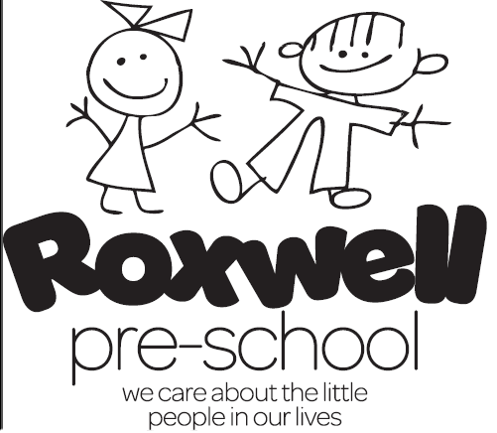

NEWSLETTER APRIL 2016
It is that time again! Easter holidays are here! Our last session at Pre-school is Thursday 24th March 2016 and we return to Pre-school on Monday 11th April 2016.
We have had a very busy and productive half term with lots of visitors! The children have learnt about many professions. The vicar, Susan, started the ball rolling followed by the firemen then the farmer, not forgetting the vet’s nurse, Joshua’s mum Fiona and their adorable assistant/patient Louis the dog. Finally the Policeman dropped in and the police van siren was a favourite! The children have all enjoyed these first hand experiences and have demonstrated great knowledge in many areas. For example, the vicar wears a dog collar, how to crawl along the floor to get out the house when there is lots of smoke as it is easier to breathe, the tractor sows the seeds that make our bread, x-rays show us what is wrong with the animals and not to go with strangers! Hooray for visitors!
We have also learnt about plants and have revived our planter with a variety of plants and herbs, our water butt, I might add, is empty due to enthusiastic watering of plants to make them grow!!
The frog spawn is now in situ in the pond and the children will learn the life cycle of the frogs next half term.
The children’s centre girls will be holding two Messy Play sessions over the Easter Break, poster is attached with details etc. to this Newsletter, and everyone is welcome!
We were Ofsteded on Tuesday the 15th March 2016 which all went well, we will hear in 10 working days what the final judgement will be, and we will let you all know as soon as the report arrives!
Our Bagstoschool Collection is the 15th April 2016, please don’t forget to give us your outgrown/unwanted clothes, shoes, jewellery and handbags, we get money for each bag donated!
Our Next Steps Meeting will be on Wednesday 20th April from 6pm-9pm with your child’s keyperson. The timeslots grid will be on the noticeboard in the front foyer from Monday 11th April 2016, please book your desired 15 minute timeslot when we get back.
Tickets are on sale for our Pirates and Princesses Party on Tuesday 3rd May from 11am-1pm. The tickets are £5 per child which includes lunch and unlimited access to the Bouncy castles! All children age 7 years and under are welcome!
Ronnie Buckingham Night is Tuesday 7th June 2016. Tickets are £15 and are limited! Please purchase as soon as possible to avoid disappointment. Tickets can be purchased from any of the staff.

Our Theme for next term is ANIMALS, THEIR YOUNG AND INSECTS
Week 1: FARM ANIMALS Mon 11th- Fri 15th April 2016
Week 2: WILD ANIMALS Mon 18th- Fri 22nd April 2016
Week 3: BIRDS Mon 25th- Fri 29th April 2016
Week 4: FISH ( MONDAY 2ND MAY BANK HOLIDAY! TUESDAY 3RD MAY PIRATES AND PRINCESSES PARTY 11AM-1PM, NO PRE-SCHOOL!) Wed 4th – Fri 6th May 2016
Week 5: LIFE CYCLE OF FROG Mon 9th – Fri 13th May 2016
Week 6: BUGS AND INSECTS Mon 16th – 20th May 2016
Week 7: PETS Mon 23rd – Fri 27th May 2016
Please encourage your child to bring something from home to put on the yellow topic tray related to the weekly themes so they can show and tell at the end of each session.
Finally have a lovely Easter Break!
The Staff.

