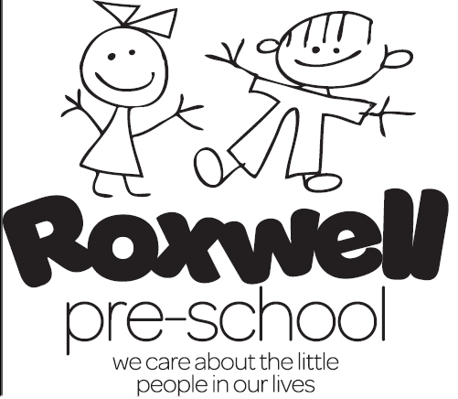

Newsletter for September 2023
The summer fun and freedom is almost over and early mornings and routines will soon bring us all back to normality!
We return to pre-school on Tuesday 5th September 2023 at 9am.
All staff will be updating their safeguarding children training on Monday the 4th September to prepare them for the coming year and learn of the new updates and guidance for keeping children safe in education. Safeguarding and Child protection is everyone’s responsibility and together we can ensure the safety and well-being of all our children. April Little is the group’s lead safeguarding officer and Yasmin Hector is our committee safeguarding officer. If you are concerned or just want to ask a question or get advice please speak to us.
We have entered the Writtle Christmas Tree festival this year for the first time ever! All entrants must have a theme/name for their tree and we are going to be creating “The Christmas Broom” an adaptation of the well-known “Room on the broom” story by Julia Donaldson. We want to be prepared for our tree to be fully decorated and designed for the display deadline of early November 2023 and therefore we will be creating “The Christmas Broom “ over this first half term and exploring the story/book “Room on the Broom” helping us to create a final masterpiece! The children will all be part of the tree and will be our little helpers when it comes to creating the characters and decorating the tree, we want Roxwell Pre-school’s entry to be recognisably an entry that is for children and created by children. You will all see the progress we make and are all invited to view our tree in all its glory in the Writtle church. The dates and times of viewing will be sent out to you all as soon as we know.
Please borrow or purchase the “Room on the Broom” book to share with your child at home and together we will all be experts on the subject as well as all being able to answer “yes” to the question, “Is there room on the broom for a boy or girl like me?” as all the children will have their spot on our “Christmas Broom” entry!
Attached to this Newsletter is information on the MMR vaccine which the Department for Education have asked us to share with you all so please do have a read through.
We ask that you all continue to hand your child over to April at the front door on arrival to pre-school each morning as we have consistently found that the children all settle much quicker when they leave their parents/carers at the door, especially our new additions!
The pickup procedure will remain the same with you all congregating at the front door at 12noon or 3pm and a staff member will welcome you all into the hall to collect your child.

Dates for your diary:
We return to pre-school on Tuesday 5th September at 9am for a 7 week half term.
We finish on Friday 20th October after the session for the October half term week.
We return to pre-school on Monday 30th October at 9am for another 7 week half term.
We finish for the Christmas break on Friday 15th December at 12noon. The children will be singing their Christmas songs on the stage on this day as well as a secret visit from Santa. All parents/carers are invited to come and watch the little singing performance at 11.30am. Children who do not attend on a Friday are welcome to swap a session or book in for an extra one off session, we want everyone to be part of this special session .More details will be given out nearer the time but please put his date and time in your diaries.
We return to pre-school on Monday 8th January 2024 at 9am.
We finish on Friday 16th February after the session for the February half term week.
We return to pre-school on Monday 26th February at 9am for a 5 week half term.
We finish on Thursday 28th March after the session for the Easter Holidays.

Our theme for the first half term is “Room on the Broom”
Week 1: Tues 5th Sept - Fri 8th Sept 2023 settling in
Week 2: Mon 11th Sept – Fri 15th Sept 2023 The broom witch
Week 3: Mon 18th Sept – Fri 22nd Sept 2023 The broom dragon
Week 4: Mon 25th Sept – Fri 29th Sept 2023 The broom cat
Week 5: Mon 2nd Oct – Fri 6th Oct 2023 The broom dog
Week 6: Mon 9th Oct – Fri 13th Oct 2023 The broom bird
Week 7: Mon 16th Oct – Fri 20TH Oct 2023 The broom frog

October half term break

Theme: On the farm
Week 1: Mon 30th Oct – Fri 3rd Nov 2023 Halloween and Fireworks
Week 2: Mon 6th Nov – Fri 10th Nov 2023 Poppies and Remembrance
Week 3: Mon 13th Nov – Fri 17th Nov 2023 Tractors and Combines
Week 4: Mon 20th Nov – Fri 24th Nov 2023 Chickens
Week 5: Mon 27th Nov – Fri 1ST Dec 2023 Pigs
Week 6: Mon 4th Dec – Fri 8th Dec 2023 Cows
Week 7: Mon 11th Dec – Fri 15th Dec 2023 Sheep

Christmas break

Theme: Space
Week 1: Mon 8th Jan – Fri 12th Jan 2024 space rockets and astronauts
Week 2: Mon 15th Jan – Fri 19th Jan 2024 sun and moon
Week 3: Mon 22nd Jan – Fri 26th Jan 2024 stars and Burn’s Night
Week 4: Mon 29th Jan – Fri 2nd Feb 2024 planets
Week 5: Mon 5th Feb – Fri 9th Feb 2024 Chinese New Year
Week 6: Mon 12th – Fri 16th Feb 2024 Shrove Tuesday and Valentine’s Day

February half term week

Theme: Transport
Week 1: Mon 26th Feb – Fri 1st Mar 2024 cars
Week 2: Mon 4th Feb – Fri 8th Mar 2024 buses and Mother’s day cream teas on Friday 8th March at 9am – 10.30am
Week 3: Mon 11th Mar – Fri 15th Mar 2024 motorbikes
Week 4: Mon 18th Mar – Fri 22nd Mar 2024 aeroplanes
Week 5: Mon 25th Mar – Thurs 28th Mar 2024 boats and Sponsored bunny bounce week

Easter Holidays

Look forward to seeing you all on the week commencing the 5th September 2023!

